NAME:
(4S,5S) -trans-3,4-dimethyl-5-phenyl-1,3-oxazolidin-2-imine
trans-2-Imino-3,4-dimethyl-5-phenyloxazolidine
trans-dimethylaminorex
4-DMAR
Direx
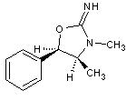
trans-Dimethylaminorex is a long-lasting synthetic stimulant which is generally found in the form of either crystals or powder which are taken orally, smoked, or insufflated. It is often touted for its use as a work-drug, especially when writing or working on long projects. It is also noted for providing somewhat more euphoria than other stimulants such as MDPV or methamphetamine. In big dose is stimilar to MDMA or cocaine. Direx use has never been particularly widespread and the material is rarely seen on the street market.
chemman added 6 Minutes and 10 Seconds later...
CHEMISTRY
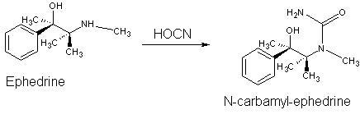
N-Carbamyl-ephedrine .Potassium cyanate (2 g., 0.025 mole) was added to ephedrine hydrochloride (5 g., 0.025 mole) in water (25 ml.), and the solution then refluxed for 24 hours, during which a small amount of oil separated, and cooled in ice-salt. The dried, white plates of the urea (3 g; 57.7%) were crystallised from ethyl acetate and then had m.p. 126-127 deg C.
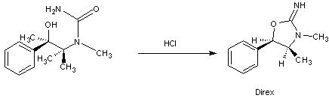
trans-2-Imino-3,4-dimethyl-5-phenyloxazolidine hydrochloride:
A solution of N-carbamyl-ephedrine (1.56 g., 0-075 mole) in water (24 ml.) and 2N-hydro-
chloric acid (15 ml.) was refluxed for 3 hours; when the clear solution cooled the crude oxazolidine hydrochloride was obtained. This was purified by conversion into the base (use Na2CO3 or K2CO3) which was extracted with benzene. The solvent was removed under vacuum from this, and the residue (direx freebase) converted into the hydrochloride (1-9g.; 84%), m. p. 225-229.
You can also use freebase to smoke or oral consumption.
chemman added 4 Minutes and 38 Seconds later...
DOSE AND EFFECTS
A standard dose of dimethylaminorex seems to run between 5 and 15 mg regardless of ingestion method (oral, insufflated or smoked). Ingestion method primarily affects the duration of the experience with smoking providing the shortest duration and oral the longest.
Oral (HCl salt)
Light: 5-10 mg
Common: 10-17 mg
Strong: 16-30 mg
Onset: 45 min - 2 hours
Duration: 10-16 hours
Normal after effects: up to 36 hours
Insufflated (HCl salt)
Light: 4-10 mg
Common: 8-16 mg
Strong: 15-25 mg
Onset: 15-45 minutes
Duration: 4-10 hours
Normal after effects: up to 28 hours
Smoke: (freebase)
Light: 3-6 mg
Common: 5-15 mg
Strong: 15-25 mg
Onset: 1-5 minutes
Duration: to 10 hours
Normal after effects: up to 28 hours
LAW
Legal in Poland
Illegal in England and USA (designer analog of aminorex)

