Hydroxylamine Hydrochloride
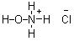
Hydroxylamine can be formed by acid hydrolysis of nitromethane[1] forming the acid salt of hydroxylamine and formic acid.
CH3NO2 + HCl + H2O → NH2OH.HCl + HCOOH
Hydroxylamine hydrochloride: 61g nitromethane was mixed with 114g 32% hydrochloric acid in a 300ml glass bottle (molar ratio CH3NO2/HCl/H2O 1:1:4.3). The top was screwed on the bottle and it was immersed in an oil bath heated to 100°C (figure 1). The solution was left at this temperature for 24 hours whereby the nitromethane and acid layers formed a homogeneous solution.
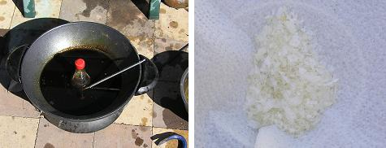
Figure 1: CH3NO2/HCl solution in oil bath (left). NH2OH.HCl crystals (right)
The solution was then transfered to a wide mouth beaker and left at the same temperature until evaporated to about 1/3 of its initial volume. On cooling the solution to -5°C hydroxylamine hydrochloride precipitated as large white flakes which were filtered and dried, further concentration and cooling yielded more crystals for a total of 41g (59%).
A similar process to that described above was used but with a molar ratio of 1:1:10, this allowed the solution to be heated in a non-pressurized vessel without significant loss of HCl, plastic film and a rubber band was used to cover the flask containing the solution. The solution was heated for 40 hours at 100°C and concentrated and precipitated as before, yield was 32g (46%).

